ECE 3332 – 301
Train Car Sorter
Amna Malik, Computer Engineer
Dylan Iden, Electrical Engineer
Cannon Thomas, Computer Engineer
Texas Tech University
Electrical and Computer Engineering Department
March 2026

Abstract
This project presents the design and implementation of an automated model train car sorting system using embedded hardware and digital control techniques. The system uses RFID identification, programmable track switches, and Digital Command Control (DCC) signaling to automatically route train cars to designated tracks. A Raspberry Pi 5 acts as the central controller, receiving identification data from RFID sensors placed along the track and determining the appropriate routing path for each train car. Based on this information, the system actuates track switches to guide the locomotive and attached cars toward their assigned destinations. The layout also includes a circular “victory lap” loop that allows continuous locomotive operation after sorting has been completed. By combining physical track infrastructure with programmable control logic, this project demonstrates how embedded systems can automate rail car routing and simulate real-world railway sorting operations on a small scale.

Table of Contents
1. Introduction 1
2. System Overview 1
2.1 Hardware Components 1
2.2 Software Framework: 2
3. Design and Implementation 3
3.1 Track Layout Design 3
3.2 Track Switching Mechanism 3
3.3 RFID Identification System 4
3.4 System Integration 5
4. Testing and Results 6
5. Engineering Standards and IP Considerations 7
6. Safety and Welfare Considerations 7
7. Global, Social, and Economic Impacts 8
8. Conclusion 8
References 10
Appendix A: Gantt Chart 11
Appendix B: Budget 12

Table of Figures
Figure 1: Overall Track Layout for the Train Sorting System 1
Figure 2: Track Layout Legend Showing System Components 2
Figure 3: Graphical User Interface for Train Sorting System Control 5
Figure 4: System Architecture of the Train Sorting Control System 6
Figure 5: Project Gantt Chart 11
Figure 6: Project Budget Estimate 12

Introduction
The organization and routing of rail cars is traditionally performed manually or through complex industrial switching systems. This project addresses the challenge of developing an automated model train sorting system using embedded hardware and digital train control techniques. The system integrates RFID identification, programmable track switches, and Digital Command Control (DCC) signaling to automatically route train cars to designated tracks. By combining physical track infrastructure with programmable control logic, the system demonstrates how embedded systems can automate rail car management on a small scale. The significance of this project lies in its ability to simulate real-world railway sorting operations using affordable hardware while providing a flexible platform for testing automation and control strategies.

System Overview

2.1 Hardware Components
The layout of the track system includes a main locomotive path, a circular victory lap loop, and a branching switch network used to route rail cars to their designated tracks. RFID sensors are placed along each track to identify individual cars before routing.
The overall track layout and switching structure used in the system is illustrated in Figure 1.
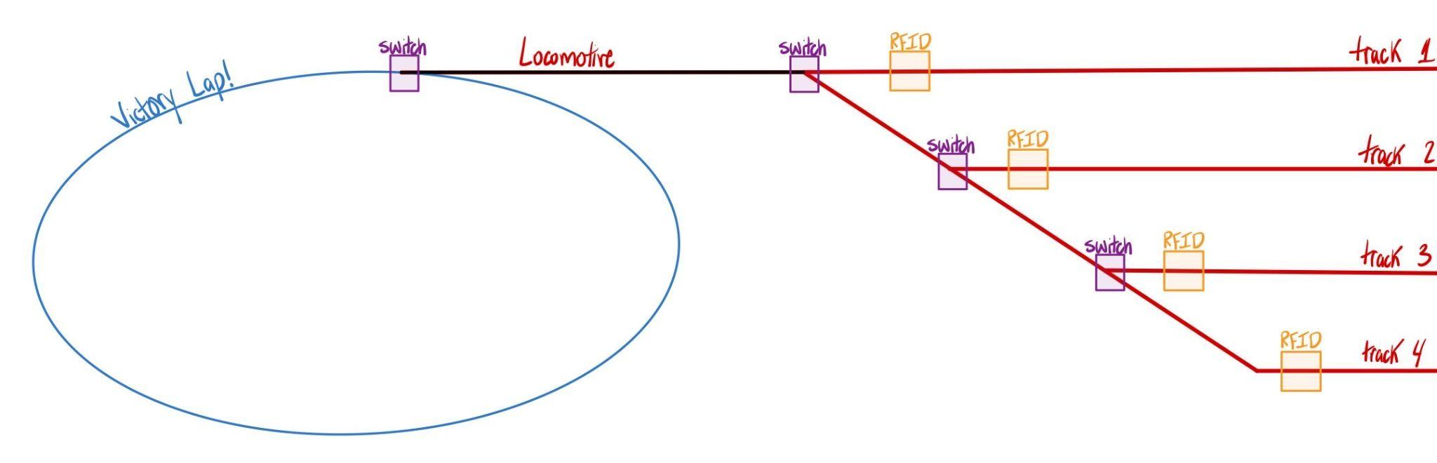
Figure 1: Overall Track Layout for the Train Sorting System
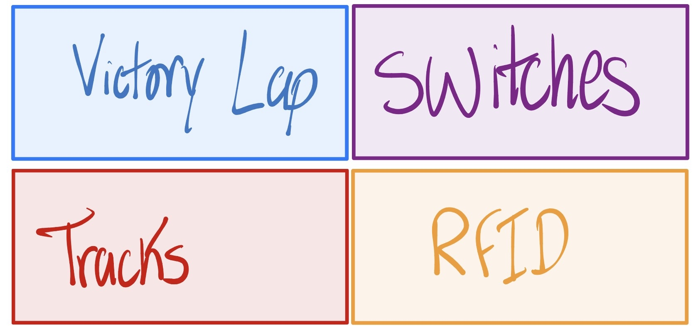
Figure 2: Track Layout Legend Showing System Components
The locomotive begins on the primary track and approaches a series of electrically controlled switches that form a branching decision structure. Each switch allows the locomotive to be directed toward one of several output tracks. By controlling the state of these switches, the system can determine which destination track the locomotive should be routed toward..
RFID sensors are positioned along the tracks in order to detect and identify individual train cars as they move through the system. Each rail car is equipped with a small RFID tag, allowing the system to recognize which car is currently being processed. When a train passes over an RFID reader, the identification information is sent to the control system where routing decisions can be made.
The victory lap loop provides a continuous circular track that allows the locomotive to keep moving after sorting operations have completed. This loop is useful for testing locomotive movement and maintaining continuous operation without requiring manual repositioning of the train.

2.2 Software Framework:
The software framework for the train sorting system is responsible for coordinating communication between the RFID sensors, the Raspberry Pi controller, and the track switching hardware. Python is used as the primary programming language due to its flexibility and strong hardware integration support available for Raspberry Pi systems.
The control software reads identification signals from the RFID sensors placed along the tracks. When a train car passes over an RFID reader, the reader transmits the identification data to the Raspberry Pi. The program then determines the correct destination track assigned to that particular rail car.
Once the routing decision has been made, the Raspberry Pi sends control signals to the electrically actuated track switches. These switches adjust the track path so that the locomotive and attached cars are directed toward the appropriate sorting track.
The locomotive itself is controlled using Digital Command Control (DCC), which allows commands such as speed, direction, and stopping to be transmitted directly through the rails. This enables the locomotive to move automatically through the switching network while the software manages routing decisions based on the RFID data.

3. Design and Implementation

3.1 Track Layout Design
The design of the physical track system was created to support automated routing of train cars while still allowing continuous locomotive movement. The layout begins with a primary track that carries the locomotive toward a branching switch network. This branching structure allows the system to route the locomotive and its attached cars toward one of several destination tracks.
A circular loop, referred to as the “victory lap,” was incorporated into the layout to allow the locomotive to continue operating after the sorting process has completed. This loop also serves as a testing area where the locomotive can be operated independently of the sorting system.
The track routing structure follows a cascading switch design. Each switch divides the path into two possible directions, allowing the locomotive to progressively move toward the correct destination track. This design allows multiple output tracks to be controlled using a relatively small number of switches.

3.2 Track Switching Mechanism
Electrically actuated track switches are used to control the direction of the locomotive as it moves through the sorting network. These switches can change the physical path of the rails, allowing the train to be directed toward different tracks.
The switches are controlled through signals generated by the Raspberry Pi controller. When the control system determines which track a train car should be routed to, it sends a command that changes the state of the required switches. This allows the locomotive to automatically follow the correct path through the track network.
The cascading switch structure allows multiple tracks to be accessed using sequential routing decisions. Each switch acts as a branching decision point that determines the next segment of track the locomotive will follow.

3.3 RFID Identification System
RFID sensors are placed at key points along the sorting tracks in order to detect and identify individual train cars. Each rail car contains a small RFID tag that provides a unique identification number when scanned by the RFID reader.
When a train passes over an RFID sensor, the identification data is transmitted to the Raspberry Pi controller. The control software then determines the correct destination track assigned to that particular train car. Based on this information, the system adjusts the track switches so the locomotive moves toward the appropriate track. This identification system allows the sorting process to operate automatically without requiring manual intervention.
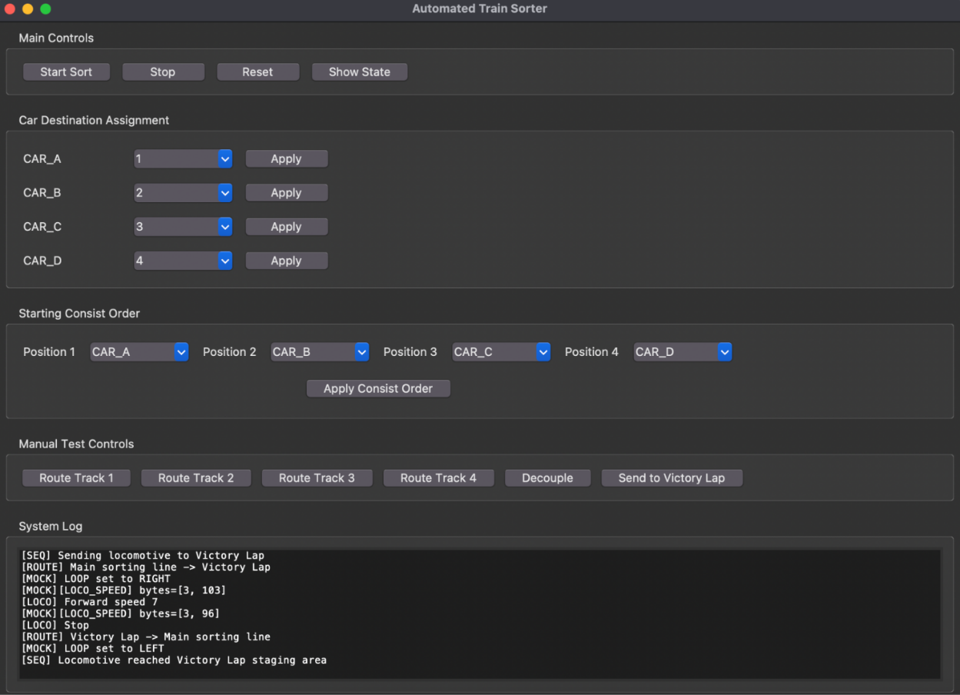
Figure 3: Graphical User Interface for Train Sorting System Control
A graphical user interface developed by Cannon Thomas allows users to monitor system status and control locomotive operations. The interface provides manual control options, automated sorting commands, and system status monitoring.

3.4 System Integration
The full system operates by combining the physical track infrastructure with embedded control logic. The locomotive begins on the primary track and moves toward the switch network. As each train car is detected by the RFID sensors, the control system determines the appropriate routing path.
Once the correct path has been determined, the Raspberry Pi sends commands to the track switches to configure the necessary route. The locomotive then continues traveling along the track until it reaches the assigned sorting location.
This integration of hardware and software allows the system to automatically sort train cars based on their identification data while maintaining continuous locomotive operation.
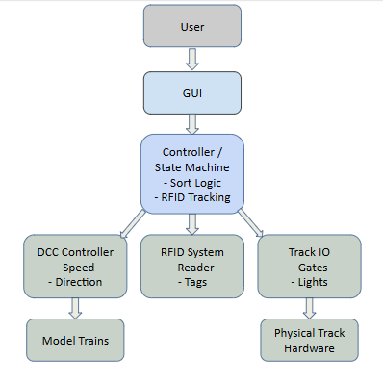
Figure 4: System Architecture of the Train Sorting Control System
The overall control architecture of the system is illustrated in Figure 4. The GUI interacts with the controller logic, which processes RFID input and sends commands to the DCC controller and track hardware.

Testing and Results
Testing of the train sorting system will focus on verifying the operation of the track layout, switching network, and RFID detection system. The locomotive will be operated along the primary track and victory lap loop to ensure reliable movement and electrical continuity throughout the rail system.
The track switches will be tested to confirm that they correctly redirect the locomotive toward the intended destination tracks. Each switch will be actuated individually to verify that the rails properly change direction and allow the locomotive to move along the selected path.
RFID sensors will also be evaluated to ensure they can reliably detect and identify RFID tags attached to individual train cars. During testing, rail cars equipped with RFID tags will pass over the readers so that detection accuracy and sensor placement can be verified.
Once individual components have been validated, the system will undergo integrated testing where RFID identification will trigger automatic track switching decisions. These tests will demonstrate the system’s ability to route train cars to their assigned tracks without manual intervention.

Engineering Standards and IP Considerations
The design and documentation of this project follow IEEE reporting and documentation standards to ensure clear communication and reproducibility. The system utilizes Digital Command Control (DCC), a widely used standard for controlling model locomotives through signals transmitted along the rails. RFID technology is also implemented using established identification practices commonly used in automation systems. All software used in this project relies on open-source tools and libraries that comply with their respective licensing agreements.

Safety and Welfare Considerations
Several safety considerations must be addressed when developing the train sorting system. Proper cable management is important to prevent loose wiring that could interfere with the track or become disconnected during operation. All electrical connections between the Raspberry Pi, RFID sensors, and track switching components must be secured to prevent incorrect wiring or accidental short circuits.
Electrical voltages within the system should be monitored using appropriate testing equipment to ensure that components operate within safe limits. Proper insulation and secure connections help prevent damage to electronic components and reduce the risk of electrical faults.
Additionally, care must be taken when operating the locomotive and switching mechanisms to ensure that moving components do not interfere with wiring or nearby hardware. Maintaining an organized and stable hardware setup helps ensure safe operation during both testing and demonstration of the system.

Global, Social, and Economic Impacts
The development of automated sorting systems demonstrates how embedded technology can improve efficiency in transportation and logistics applications. While this project operates on a small-scale model railway, similar automation concepts are widely used in large freight rail systems to organize and route cargo efficiently.
The use of affordable hardware such as the Raspberry Pi and RFID sensors also highlights how low-cost technologies can be applied to automation problems. This makes the system useful not only for transportation demonstrations but also for educational environments where students can learn about embedded systems, automation, and control systems.
By combining accessible hardware with programmable control systems, this project demonstrates how modern automation techniques can be explored in a cost-effective and educational manner.

Conclusion
This project presents the design and development of an automated train car sorting system using embedded hardware and programmable control techniques. The system integrates RFID identification, Digital Command Control (DCC), and electrically actuated track switches to create a platform capable of automatically routing train cars to designated tracks.
At this stage of development, the physical track layout and overall system architecture have been designed to support automated routing operations. The system structure allows train cars to be identified through RFID sensors while the Raspberry Pi controller determines the appropriate routing path through the switching network.
Future development will focus on completing system integration and performing full testing of the RFID detection system, switch control mechanisms, and locomotive routing functionality. These steps will allow the system to demonstrate fully automated train sorting operations in the final implementation.

References
- National Model Railroad Association, “Digital Command Control (DCC) Standards,” NMRA, https://www.nmra.org/index-nmra-standards-and-recommended-practices (accessed Mar. 2026).
- Raspberry Pi Foundation, “Raspberry Pi Documentation,” https://www.raspberrypi.com/documentation/ (accessed Mar. 2026).
- RFID Journal, “RFID Basics,” https://www.rfidjournal.com/rfid-basics (accessed Mar. 2026).
- Python Software Foundation, “Python 3 Documentation,” https://docs.python.org/3/ (accessed Mar. 2026).
- Riverbank Computing, “PyQt Documentation,”
https://www.riverbankcomputing.com/software/pyqt/ (accessed Mar. 2026).
- Iden, Dylan. Microsoft PowerPoint, 10 Mar. 2026.
- Thomas, Cannon. Microsoft PowerPoint, 10 Mar. 2026.

Appendix A: Gantt Chart
Below is the project timeline and task progress for the automated train sorting system. The chart outlines planned development stages, assigned responsibilities, and the projected progression of the system development.
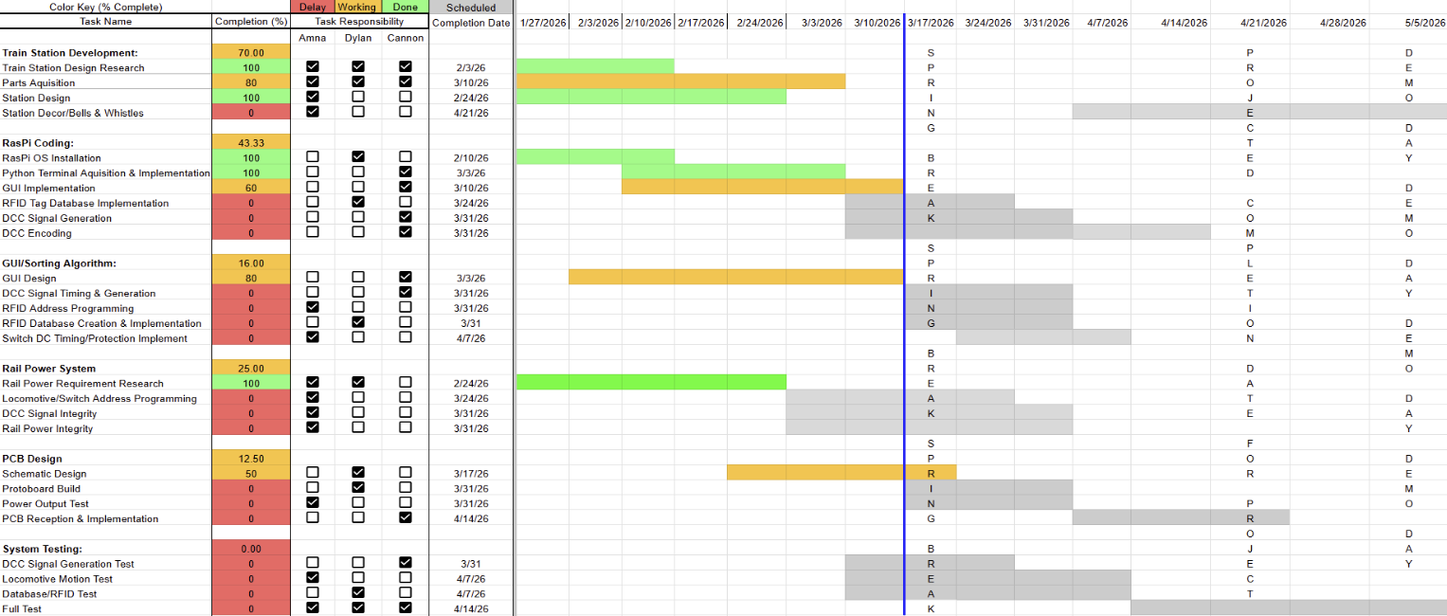Figure 5: Project Gantt Chart

Appendix B: Budget
Below is the project budget estimate for the automated train sorting system. The table summarizes expected costs for materials, electronics, and other components required for system development.
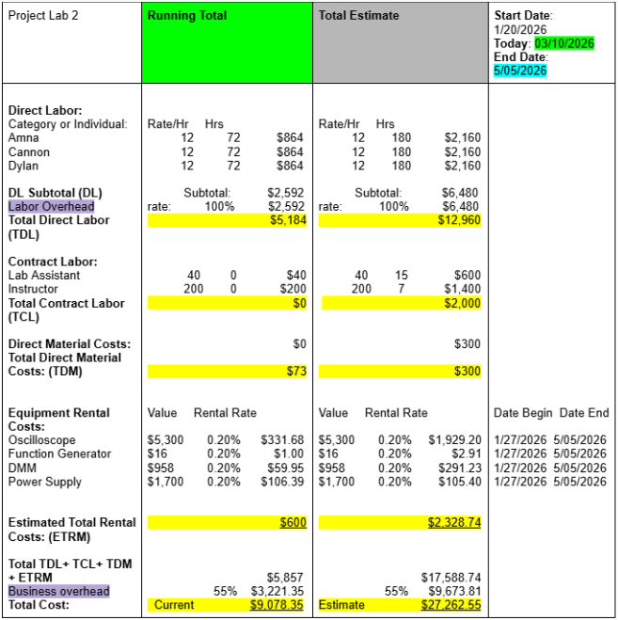
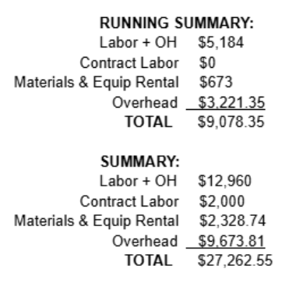
Figure 6: Project Budget Estimate

